1 Student = One Example  
  
Condition = Should not get match with other student

1) Akash Todkar

One way to measure a person’s fitness is to measure their body fat percentage. Average body fat percentages vary by age, but according to some guidelines, the normal range for men is 15-20% body fat, and the normal range for women is 20-25% body fat.

Our sample data is from a group of men and women who did workouts at a gym three times a week for a year. Then, their trainer measured the body fat.

Group Body Fat Percentages

Men 13.3,6.0,20.0,8.0,14.0,19.0,18.0,25.0,16.0,24.0,15.0,1.0,15.0

Women 22.0,16.0,21.7,21.0,30.0,26.0,12.0,23.2,28.0,23.0

2)Vidya Kothavale

The thickness of ceramic tile of vendor A is slightly greater than the vendor 2. The researcher randomly collected samples from both vendors. Assuming the population variances are equal, at 95% confidence level, is there enough evidence to support the claim?

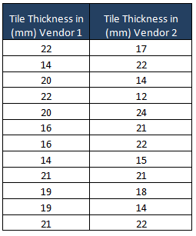

3)Shubhangi Dighe

concerning the mean satisfaction levels of customers of two competing cable television companies. Test at the 1% level of significance whether the data provide sufficient evidence to conclude that Company 1 has a higher mean satisfaction rating than does Company 2. Use the critical value approach.

4)Pansare Komal

Samples of sales in similar shops in two different US states are taken for a new product with the following results. Is there any evidence that sales in state A is less than the state B. Assuming the population variances are equal, at 95% confidence level, is there enough evidence to support the claim?

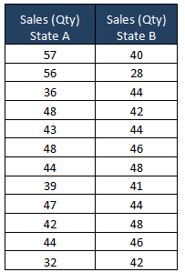

5) Suvarna Nimonkar

To compare customer satisfaction levels of two competing cable television companies, 174 customers of Company 1 and 355 customers of Company 2 were randomly selected and were asked to rate their cable companies on a five-point scale, with 1 being least satisfied and 5 most satisfied. The survey results are summarized in the following table:

Company1 Company2

n1=174 n2=355

avg( x1)=3.51 avg( x2)=3.24

s1=0.51 s2=0.52

a point estimate and a 99% confidence intervall for μ1-μ2, the difference in average satisfaction levels of customers of the two companies as measured on this five-point scale.

6) Arjun Walunj

A group of 5 patients treated with medicine. A is of weight 42,39,38,60 &41 kgs. Second group of 7 patients from the same hospital treated with medicine B is of weight 38, 42, 56, 64, 68, 69, & 62 kgs. Find whether there is any difference between medicines?

7) Manali More

What percentage of movies do men and women find horror. We asked 12 people to watch a movie and rate that particular movie. After watching each person gave a rating.

Men : 40 45 39 49 50 43

Women : 70 80 89 76 90 87

8) shivam shastri

Suppose that we are interested in assessing the effectiveness of a Social Skills Training (SST) program for alcoholics that are in a rehabilitation program. Assume that nx = 12 patients (the control group) participated in the normal treatment program, and ny = 11 patients (the test group) participated in the SST supplement in addition to the normal treatment program.

x <- c(1042, 1617, 1180, 973, 1552, 1251, 1151, 1511, 728, 1079, 951, 1319) >

y <- c(874, 389, 612, 798, 1152, 893, 541, 741, 1064, 862, 213)

9) Suraj bawane

Find the t-test value for the following two sets of values: 7, 2, 9, 8 and 1, 2, 3, 4?

10) Suraj

Two independent samples 8 and 7 items respectively had the following values :

Sample I : 9 11 13 11 15 9 12 14

Sample II : 10 12 10 14 9 8 10

If the difference between the means of samples is significant?